Boiler detail design

DOC. No.: | REV.: 00 |  |  | PRODUCT:
TITLE: Boiler detail design |  |  |  | Project:
Prepared by: | Lewis Chen |  |  | Date:
Remark: | Approval:
Remark: |  | Department | Title |  |  | Signature
Remark: | 1 | Electronic R&D
Remark: | 2
Remark: | 3
Remark: | 4

Revision | Description of Change | Author | Date
00 | Complete the boiler detail design document | Lewis Chen | 2010.7.15
01 | Use EVA error code to define our error | Lewis Chen | 2010.715

1. Boiler overview 4
2. The mechanical of boiler 4
2.1. Hot water boiler and steam boiler 4
2.2. The plastic instant boiler 4
2.2.1. Calibration plastic instant boiler 5
3. Boiler heating control 5
3.1. Boiler heating state 5
3.2. Boiler heating state flowchart 6
4. Boiler error code define 6
5. To be continue 7
5.1. Objective 7
5.2. Scope 7
5.3. Reference 7
5.4. Abbreviations 7
5.4.1. heading3 7
Appendix 8

Boiler overview
There are different kinds of boiler in the vending machine. Such as esboiler, instant boiler and plastic instant boiler are the most in use boilers in the recently developed machine.
Except plastic instant boiler, the mechanical structure of the other boilers is nearly the same. But as a heating unit, the temperature control algorithm is also nearly the same.

The mechanical of boiler

Hot water boiler and steam boiler
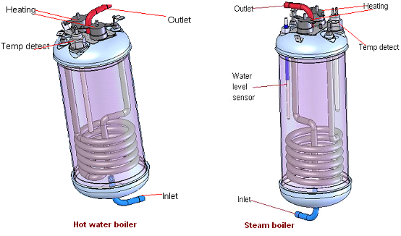
As the function of hot water boiler is different from steam boiler. Their mechanical structure is not the same. Steam boilers have water level sensors, but hot water boilers don’t. Ignore the water level sensor, the structure of hot water boiler is the same with steam boiler.

The plastic instant boiler
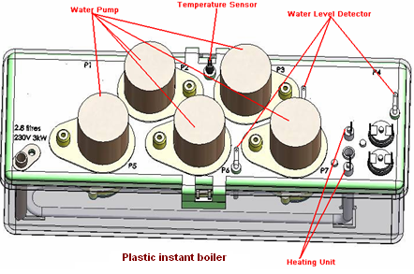
The plastic instant boiler is a special boiler which contains water pump in it. When PWM signal is gave to the pump motor, the water inside can be pumped out.

Calibration plastic instant boiler
Because of the length of the water pipes which the water pumps are connected to are different, to make the dosing process more precisely. The pumps of the PIB have to be calibrated.

Here is the calibration process shows in the following flowchart.
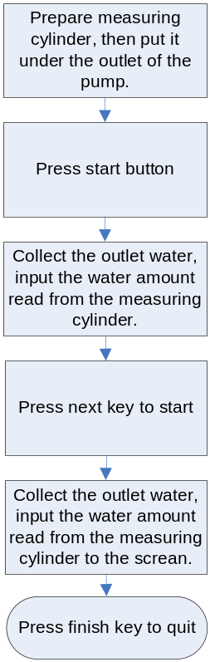

NSL1000 water system introduction.

Main nsl1000 water system feature.
- 3000W boiler with soft power regulator to meet the deferent country power requirement.
- Boiler water temperature tolerance is limited in 1 degree.(above the setting value, for example, if the temperature setting is 93 degree, the tolerance will be 93-94 degree)
- Adjustable the outlet water temperature is implemented with a cold water pump mixing with hot water, only for low pressure product.
- Fast hot water dispenser, 250cc long coffee product with 6cc/s, the waiting time is 16 second and 120 instant product with 20cc/s, the waiting time is 22 second in there is not cold water mixing function, if there is cold water mixing with hot water, waiting time is 16 second.
- Adjustable the pressure control water system for espresso.

Boiler heating control

Boiler heating state
There are seven states while boiler is heating water shows in the following enumeration.

typedef enum {
START_INITIAL_HEATING = 0,
TEST_BOILER_FILLED,
CALCULATE_HEATING,
START_HEATING,
WAIT_HEATING,
WAIT_STABILZING,
FORCED_SHUT_DOWN
}HEAT_STATE;

The boiler state will change as the heating going on.

Boiler heating state flowchart
To make the state switch process more clear, here is the flow char of heating control as follow.

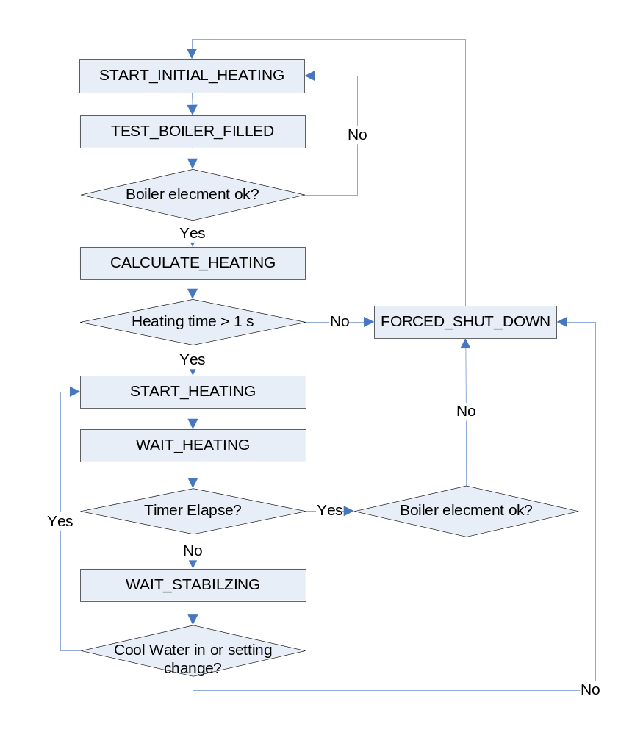

NSL1000 boiler heating control algorithm

Main electronic hardware resource list.
- PT1000 temperature sensor is for boiler water
- Thermal couple temperature sensor is for boiler outlet water sensor.
- Gear pump is for hot water, ac piston pump is for cold water mixing.
- LPC1114 cpu main responsibility is for water dosage, and ADI aduc7061 is 24bit adc with amplifier to process the temperature sensor and pressure sensor.

Main firmware module for the water system.

Aduc 7061 firmware module.
- ADC scan module: the main function of this module is to scan the all of required ADC channel.
- Boiler controller module: It implement the core algorithm of the boiler heating time calculation that base on the traditional PID algorithm.
- Pump mix module: it control the ac cold water piston pump flow rate to get the adjustable the outlet water temperature. Also base on PID algorithm.
- I2c handler module, it communicate with the LPC1114 cpu.

LPC1114 firmware module.
- Water dosage module: control the water dosage.
- Boiler heater module: it detect the boiler status, and if the boiler and control unit hardware status are ok, it will poll the heating time with the adi chip boiler controller module.
- I2c handler module: it communicates with the adi chip to get the sensor result.
- sl bus handler module: communicate with io board to process the water system command sets.

Boiler heat time controller algorithm.
- Main concept of the boiler heat time controller.
The boiler heat time controller has two input factor: boiler current temperature and current water flow rate, and output is boiler heat time, so normally like this formula:
heat_time=f(t,flowrate).
Another important factor is energy required to heat the water to setting temperature, so the controller will count the flow rate of the water dosage to get this value. Define this factor is WTe, and the unit 0.1 joule.
- Real boiler controller is used in NSL water system.
heat_time = Kp*Terror+Ki*Wte+Kd*TDerror+Kf*WTflowrate
    - Kp,Ki,Kd,Kf are adjustable factor of the controller.
    - Terror = Temperature setting – boiler temperature
    - TDerror = delta error temperature value.
    - WTe = Required energy to heat the water incoming.
    - WTflowrate= Flow rate of water dosage.
    - The item Ki*Wte is included when the water temperature is getting down or the energy is getting up.
This module is run in ADuc7061 chip, and the heat time is polled by the LPC1114 heater module.
- Boiler heater module.
This module main responsibility is to poll the heat time and then heat the boiler.

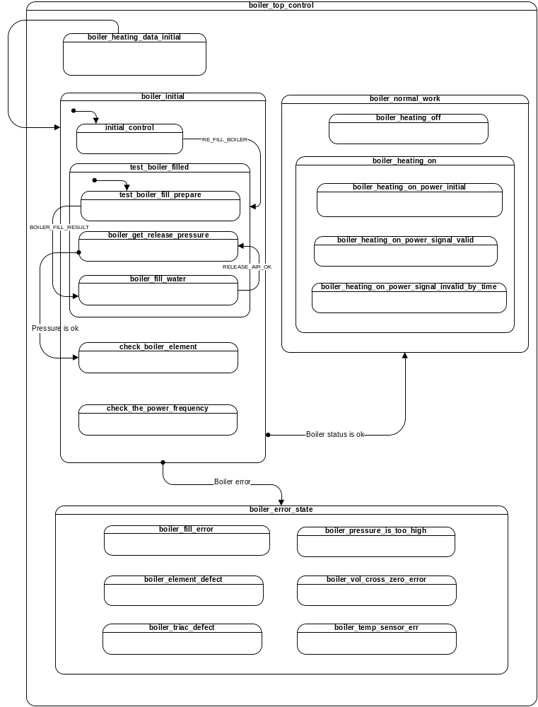

Boiler heating power regulator.
The boiler heater module contain one boiler heating power regulator, because when the boiler temperature close to the target, the boiler must switch to small power mode to get the stable temperature, otherwise the boiler will get over heating.
So the 1/8,2/8,… Full power mode is implement in the software, and boiler heater module will select the power mode according to the heat time and the max system available power(13A power limit issue) automatically.

Software power regulator intrudocution
Signal description:
Ch3: heat signal.
Ch2: cross zero signal
Ch4: boiler current
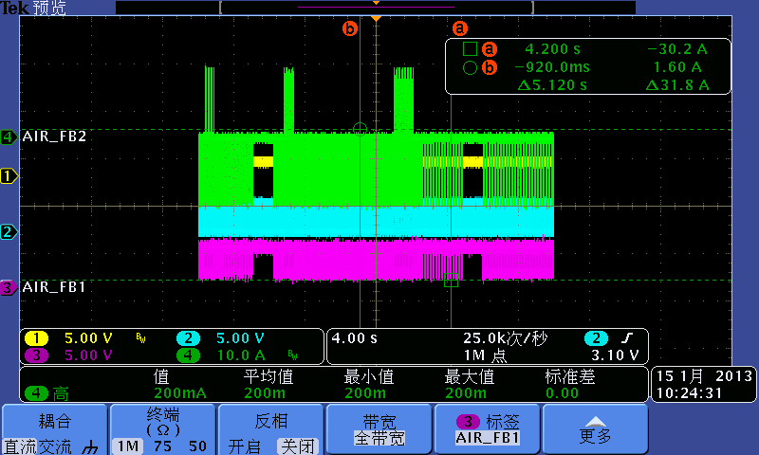
Figure 1: the boiler power changing overviem in about 20s
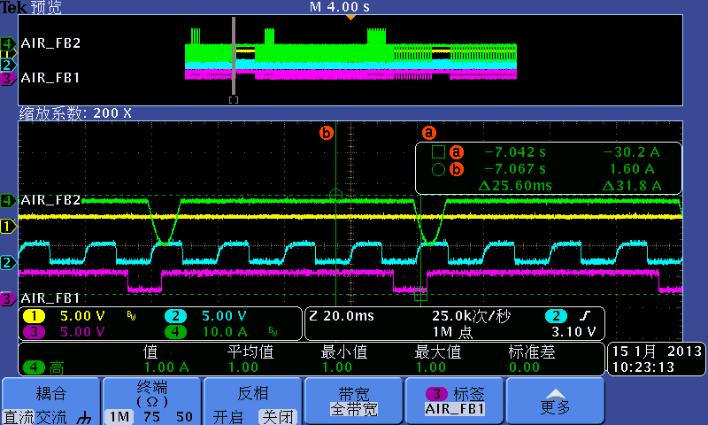
Figure 2: 1/8 power signal:
The heat signal is turn on one circle (10ms), then off 7 circles.
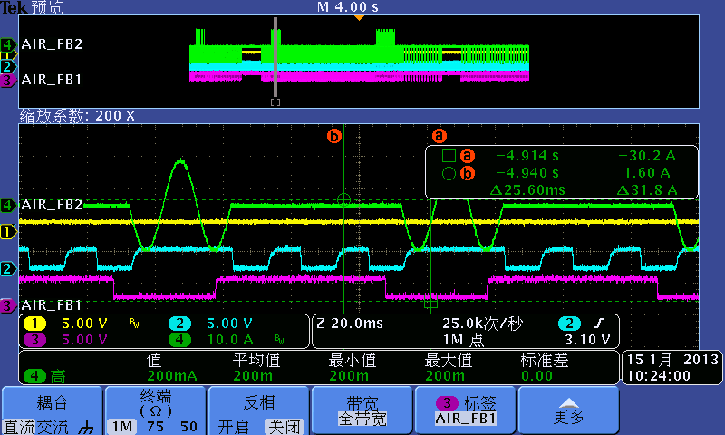
Figure 2: 3/8 power signal:
The heat signal is turn on 3 circles (10ms), then off 5 circles.
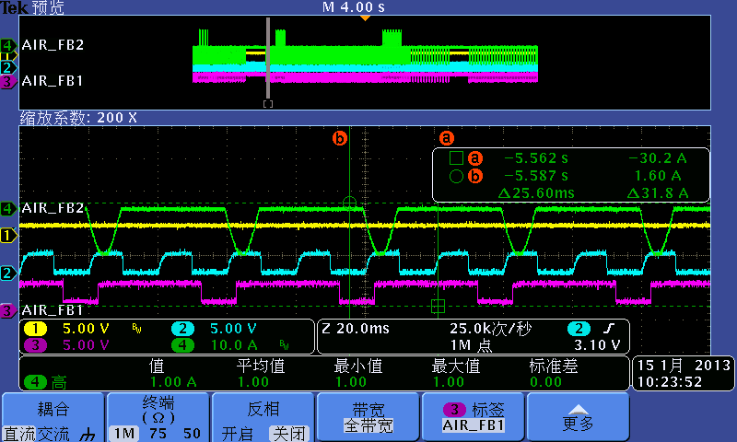
Figure 2: 1/4 power signal:
The heat signal is turn on 1 circle (10ms), then off 3 circles.

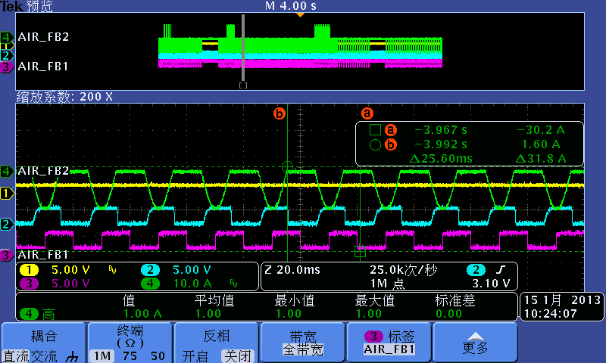

Figure 2: 1/2 power signal:
The heat signal is turn on 1 circle (10ms), then off 1 circle.
.

Boiler error code define
EVA error code | Event description | Definition | Is Fatal | Remarks
EFG | Boiler empty | Boiler is not completely filled. | Yes | E_BOILER_EMPTY
EDM | Boiler sensor | Boiler sensor reading out of range. | Yes | E_BOILER_NTC_ERR
EDL | Boiler heating element | Boiler heating element defects. | Yes | E_BOILER_ELEMENT_DEFECT
EFC | Water supply failure | No flow detected | Yes | E_NO_FLOW
EFL | Low pressure | Not enough flow detected | Yes | E_SLOW_FLOW
EFO | PIB Pump motor 1 defect | PIB Pump motor defect. | No | E_PIB_MOTOR1_NOT_PRESENT
EFO_1 | PIB Pump motor 2 defect | PIB Pump motor defect. | No | E_PIB_MOTOR2_NOT_PRESENT
EFO_2 | PIB Pump motor 3 defect | PIB Pump motor defect. | No | E_PIB_MOTOR3_NOT_PRESENT
EFO_3 | PIB Pump motor 4 defect | PIB Pump motor defect. | No | E_PIB_MOTOR4_NOT_PRESENT
EFO_4 | PIB Pump motor 5 defect | PIB Pump motor defect. | No | E_PIB_MOTOR5_NOT_PRESENT
EFO_5 | PIB Pump motor 6 defect | PIB Pump motor defect. | No | E_PIB_MOTOR6_NOT_PRESENT
EFO_6 | PIB Pump motor 7 defect | PIB Pump motor defect. | No | E_PIB_MOTOR7_NOT_PRESENT
EFG_1 | PIB empty | Plastic instant boiler empty. | No | E_PIB_EMPTY

To be continue

Objective

Scope

Reference

Abbreviations

heading3
Normal

Appendix

